WHAT THE UNITED NATIONS CAN AND CAN’T DO
Take into account when writing your resolution that the United Nation's realm of action is limited. The U.N., which is an organization composed of its member states, not a separate entity on its own, has a few specific tools that it can use to achieve solutions to a wide variety of problems. The U.N. has a budget that it raises through fundraisers, partnerships with private and non-profit organizations, and dues from member countries.
Can
- It can use the money in its budget to buy supplies and equipment and pay employees to carry out programs all over the world.
- The U.N can also use its money and personnel to do research on world problems/conditions and possible solutions.
- The U.N. has arbiters and negotiators on its payroll that it can send to troubled areas to try and prevent the breakout of violence or to try and restore peace after a conflict has occurred.
- The U.N. can call for nations or groups to come to the table to discuss their conflicts and appoint another, uninvolved nation to arbitrate, if that nation agrees.
- The U.N. can also call for summits or meetings to solve special problems.
- The U.N. can set up new committees whose main responsibilities will be to oversee the progress on a certain topic or subset of topics.
- The U.N. has peacekeepers that can be sent to conflict areas.
- The U.N. can call for economic sanctions on a country in an attempt to coerce that country into accepting U.N. regulations on, for example, human rights or nuclear non-proliferation.
- The U.N. can educate and encourage populations to act in certain ways.
Can't
•The U.N. cannot, however, make laws, prohibit or impose behavior on either individuals or nations. •The U.N. cannot make war on any nation or violate any nation's sovereignty, or interfere with the right of each nation's government to make and enforce its own laws.
• The U.N. cannot force any nation to join in imposing sanctions on another country.
The U.N. relies largely on the powers of persuasion, diplomacy, and the cooperation of its component member states.
FORMAT INSTRUCTIONS
IMPORTANT: The structure of a resolution is always ONE SENTENCE. There is only ONE period. Each line should be numbered when you are finished writing the resolution.
A RESOLUTION HAS FOUR PARTS:
1. Heading
The heading serves as identification for the resolution, and informs the reader of three things:
1) WHERE the resolution will be submitted - the body .in which the resolution is initiated,
2) WHAT is the topic of discussion - the topic or problem addressed by the resolution, and
3) WHO is the author (or authors) - the body (country) proposing the resolution. See example resolution #1 where the heading is bracketed. Can you find the heading on example #2?
2. Subject
Just as every sentence has a subject, so must every resolution. The subject tells you WHO will be taking the action. Look at example resolution #1, the subject is bracketed. Can you find the subject on example #2?
3. Preambulatory Clauses
The preamble is the first half of the resolution. It explains in a logical sequence WHY the action in the operative clauses is being suggested. It states past action, reasons for the action, and sums up your reasons for concern. Referring to action on the issue taken in the past by the United Nations makes the resolution very authentic and gives it a realistic foundation for the new proposal included in the operative clauses of your resolution.
The first word of each preambulatory clause should set the "tone" for the statement which follows (and therefore must be in bold type, ALL CAPS, AND/OR underlined). Tone has to do with the strength of your conviction about the topic. Therefore, the stronger your conviction about a statement, the stronger the first word.
IMPORTANT: Each clause in the preamble is followed by a comma (,) plus the word "and." The last clause in the preamble is followed by a colon (:). Go to the example resolutions. Can you find the preambulatory clauses in each resolution?
Some possible initiating phrases for preambulatory clauses:

Acknowledging  Affirming  Alarmed  Anxious  Appreciating  Approving  Aware  Bearing in mind  Cognizant  Concerned  Confident  Conscious  Considering  Contemplating  Convinced  Declaring  Deeply disturbed  Desiring  Deploring  Determined  Emphasizing  Being convinced  Keeping in mind | Encouraged  Endorsing  Expressing  appreciation  deep appreciation  Expecting  Fulfilling  Fully  aware  believing  bearing in mind  Grieved  Guided by  Having  adopted  approved  considered  decided  examined further  received  regard for  reviewed  viewed with apprehension Mindful | Noting  further  with approval  Noting (cont.)  with deep concern  with regret  with satisfaction  with grave concern  Observing  Reaffirming  Realizing  Recalling  Recognizing  Referring  Regretting  Reiterating  Seeking  Stressing  Taking  into account  into consideration  note  Welcoming

4. Operative Clauses
The operative clauses of a resolution tell the reader what ACTION is being proposed to solve the problem described in the preamble. The operative clauses should be the strongest part of your resolution. (HINT: When you propose actions to be taken, they may require funding. It's a good idea to take this into consideration when you write your resolution.)
Remember to INCLUDE AT LEAST TWO OR THREE operative clauses in your resolution. Resolutions submitted containing one or no operative clauses will be sent back as unacceptable.
The first word or phrase (for examples, see below) of each operative clause is a verb, indicating the clause which follows. It must be in bold, ALL CAPS AND/OR underlined. Language and tone play an important part in determining the strength of your operative clauses.
IMPORTANT: Each operative clause is numbered, in addition to the line numbers to the left of each line of the resolution — look at the examples. Each operative clause ends with a semi-colon (;) plus the word "and", except for the last, which is followed by a period (.). For operative clauses containing several subclauses, each subclause should be preceded with a letter and followed by a comma (,). The second to last sub clause should end with ", and" and the last should end with "; and".
Some possible initiating phrases for activating or operative clauses:

Accepts | Expresses | Regrets
Adopts | its appreciation | Reiterates
Affirms | conviction | Renews its appeal
Appeals | its regret | Repeats
Appreciates | sympathy | Suggests
Approves | thanks | Supports
Authorizes | the belief | Takes note of
Calls Upon | the hope | Transmits
Commends | Further | Urges
Concurs | invites | Welcomes
Condemns | proclaims
Confirms | reminds
Congratulates | recommends
Considers | requests
Decides | resolves
Declares | Instructs
Deplores | Reaffirms
Designates | Recognizes
Directs | Recommends

5. Line Numbers
After the resolution is finished, beginning with the Subject, put line numbers on each line of the resolution, (see example on next page).

TYPING AND MAILING RESOLUTIONS
When typing your resolution, please refer to the Format Instructions on the previous pages. AFTER typing the resolution, don't forget to add line numbers, along the left side of the page (see examples). NOTE: If you use Microsoft Word, turn autoformat OFF.
**EVIPORTANT:** Only ONE resolution per country per committee will be accepted.
If a delegate writes more than one resolution, submit only ONE through the mail. Others may be brought to the conference and submitted as New Business, to be debated if time permits. If more than one is mailed, the Chair may discard all resolutions from that country.
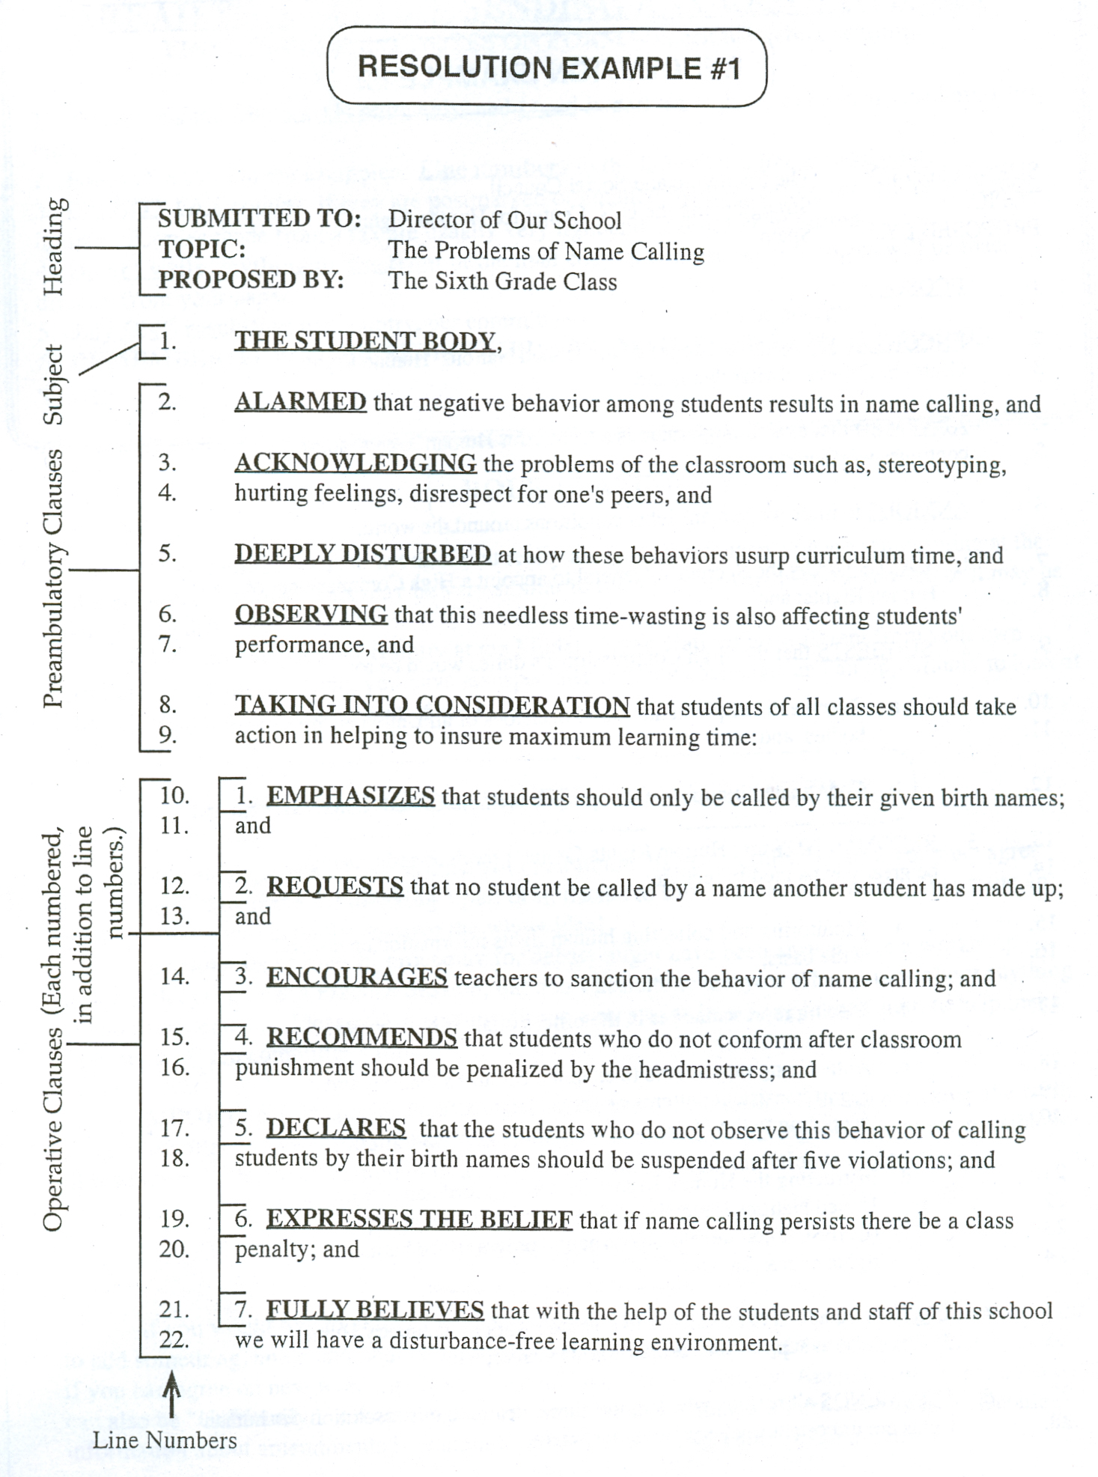

RESOLUTION EXAMPLE #2

SUBMITTED TO: The Economic and Social Council
TOPIC: Strengthening the U.N. Center for Human Rights
PROPOSED BY: Spain

1. ECOSOC.

2. ENCOURAGED by the existence of the United Nations' Human Rights
3. Center in Geneva, Switzerland, and

4. ALARMED that even though there is a Center for Human Rights, abuse
5. continues world wide, and

6. ANXIOUS to improve human rights conditions around the world:

7. 1. CALLS UPON the Secretary-General to appoint a High Commissioner of
8. Human Rights; and
9. 2. SUGGESTS that the High Commissioner's duties would be to:

10. a. Oversee the implementation of decisions of all United Nations human rights
11. bodies, and

12. b. Coordinate all human rights programs in the United Nations system; and

13. 3. RECOMMENDS that Human Rights Center's services and programs
14. be greatly expanded to include:

15. a. Monitoring and collecting human rights information on a world-
16. wide basis,

17. b. Placing representatives in the offices of all U.N. agencies,

18. с Authorizing rapporteurs to examine country situations and
19. report consistent patterns of gross violations of human rights,
20. according to the Universal Declaration of Human Rights, and

21. d. Instructing the Human Rights Center, in coordination with
22. United Nations Educational Scientific and Cultural Organization
23. (UNESCO), to develop more active programs for human
24. rights education; and

25. 4. URGES all nations to contribute to a United Nations Voluntary Human
26. Rights Fund to support the Human Rights Center; and

27. 5. COMMENDS all nations who support these ideas and this resolution, for human
28. rights are important to everyone in our world.

ROLE-PLAYING

**READ THIS BEFORE SENDING ANY RESOLUTIONS!**
FINAL IMPORTANT NOTES ON FORM -- check list before sending:
1. Resolutions must be one (1) page only, and typed in dark enough ink to be easily read after being copied.
2. Follow the form in the examples. Line numbers to the left of each line are essential.
3. DO NOT FAX copies! If they are postmarked or emailed by the deadline, we will receive them in time. (Copies made from a fax are usually very light and will not be accepted.)
4. Do not write anything on the front of the final copy of the resolution -- copies will be made directly from your paper.
5. Only ONE resolution per country, per committee will be accepted.
6. REMEMBER, IT IS YOUR RESPONSIBILITY: MAIL YOUR RESOLUTIONS ON
TIME!

Role-playing means to act as if you really are from the country you are representing at the Model United Nations. This may be very similar to the way you usually think and act, or it may be completely different.
If the policies of your country at the Model United Nations are different from your own personal ideas about a topic, you have an especially difficult challenge, and an opportunity to look at the subject from a different point of view.

DEBATE IN COMMITTEE AND USE OF TIME

If someone gives a speech against your resolution, listen carefully, because you may agree with the point they make for disliking a part of it, decide to call for a caucus, and together write an amendment that will actually improve the whole idea!
Questions about rules of procedure for debate might have been answered in a workshop earlier in the year, or at a Practice Session, but don't hesitate to ask your Chairperson about anything you don't understand. Please ask questions during a recess, or in writing to the Chair, to help make the best use of the committee's time.

IMPORTANT, PLEASE NOTE: Each delegate can do his/her share to help keep the work of the committee moving smoothly and efficiently. If everyone works together, it is very possible for all resolutions to be given sufficient time and receive the full consideration they deserve.

AMENDMENTS

If you would like to vote for a resolution, but can't agree with every point it contains, or want to add something, an amendment is in order. Caucus with the author of the resolution first, to see if you can agree on new wording. If so, it would be called a "Friendly" Amendment. Amendments can also be "Unfriendly." Amendments are written on an Amendment Form (next page). Detailed information about amendments is contained in the Rules of Procedure - Long Form.

CAUCUSING

Caucusing is informal discussion about the topics being debated in each Committee. A motion to caucus is in order when a delegate sees the need for clarification between two or more opposing points of view.
Caucusing is one of the best tools available to all delegates. During caucuses you will have a great opportunity to promote your ideas. As persuasive as is your speech supporting your resolution, it will not have the impact of face-to-face negotiations.
Caucusing can take place between you and your allies as well as your adversaries. There may be some nations that formally would not meet to negotiate, but under the informal and private conditions of a caucus, they might have the opportunity to come to an agreement on an issue.

COMBINING RESOLUTIONS

It is not uncommon to find one or more resolutions in the Packet similar to yours. If several resolutions are too similar, the majority of them will not receive the attention they deserve from the committee. The best plan is to work together to CO-SPONSOR one resolution which presents a combination of all the ideas. Co-sponsoring may involve changing details of your original resolution, but the main idea or purpose stays the same. Each co-sponsor will be able to give their speech in support. The resolution becomes stronger, and has a much better chance of being agreed upon by the whole committee.
Consider locating and speaking to the author(s) of the similar resolution(s) as soon as you arrive at the Model United Nations. This might be possible during registration, or you can call for caucus time once your committee is in session. Remember, only compromise on details, not the main purposes you have in mind. If you need help, ask your Chair.

IF YOUR RESOLUTION IS TABLED

If your resolution is tabled for any reason, don't panic. During a recess, go to your Chairperson, and ask him/her what to do. They will be glad to help you, and will do all they can to see that your resolution has a chance to be considered and voted on by the Committee.

RULES OF PROCEDURE -- LONG FORM

Scope of Rules:
The rules in this handbook are the official rules of GEMUN and will be used throughout the GEMUN conference for the orderly conduct of business. No other rules of order or procedure shall apply.

COMMITTEE RULES

Quorum:
At the first formal session of the Committee, the Chair shall call the roll to determine which delegations are present. The number of delegations present at the time of the roll call determines whether or not there is a sufficient number of member countries to conduct business (quorum). Members must signify 'present and voting' at opening roll call in order to establish voting privileges for their nation. If they come in late to the session, they must notify the Chair in writing. At least one-third of all delegations must be present for business discussion to occur. A majority of delegations must be present for voting to take place.

Agenda:
1. The Secretariat will arrange the resolutions numerically and in a logical order according to topic and country. The order of the agenda corresponds with the numbers in the top right corner of each resolution.
2. The order of the agenda may only be altered at the discretion of the Chair.

Debate:
1. Representatives must have the Chairperson's permission to address the body. The Chairperson may choose to formulate a Speakers List from those delegates signifying a desire to speak.
2. If the committee has limited the time of debate, the Chairperson shall call a delegate to order if s/he has exceeded his/her allotted time.
3. If a delegate's speech on a proposal has time limitations, s/he may also yield to Points of

Information regarding the topic at hand, within an additional time allotment.
4. When the debate for a resolution is completed, before the next scheduled recess, the Chair may elect to grant the Right of Reply. Right of Reply is an opportunity to counter an inaccurate or insulting statement made by another delegate. Requests for the Right of Reply must be submitted to the Chair in writing. The Chair may limit the length of the delegate's reply time. Decisions to grant, or not to grant, the Right of Reply shall not be subject to debate or vote. (C-l Right of Reply)*

♦See "RULES OF PROCEDURE -- SHORT FORM"
Amendments:
1. A motion is considered an Amendment to a resolution if it adds to, deletes from, or revises any part of that resolution. All amendments must be submitted in writing to the committee Chair before they are considered by the body. Copies of the Amendment Form are available from the committee Chair. .
2. A Friendly Amendment to a resolution has the support of the author and the co-sponsor(s) of the resolution being amended.
When a Friendly Amendment is moved, the Chair shall ask each of these parties if they accept it. If accepted, the Friendly Amendment is part of the resolution. If it is rejected by any of these parties, it shall not be considered a Friendly Amendment. Friendly Amendments must be labeled as such when submitted to the committee Chairperson.
3. If an amendment is rejected by either the author of the resolution, or co-sponsor(s), it shall be deemed an Unfriendly Amendment. At the Chair's discretion, debate will begin on the amendment.
4. The Chair may rule "out of order" any amendment which is judged to be a waste of the committee's time. Amendments of this nature, for example, might change the intent of the resolution or make trivial or absurd changes in its wording.
5. A secondary amendment must relate to the primary amendment and the main motion. Resolutions may only be amended twice.
6. One purpose of the amendment process is to combine two resolutions with similar goals. In doing so, the committee can accomplish the goal of both delegates and move through one resolution in less time than it would usually take the committee to move through two.

Motions: *NOTE: Any motion may be ruled "out of order" by the chair if there is not sufficient time or reason to execute it.
1. Any representative may move to Limit or Extend Time of Debate. The motion may limit the number of speakers, the number of times a representative may speak on a question, the length of speeches, the length of debate on a particular resolution and/or topic, or any combination of the above. The motion requires a 2/3 vote, and is debatable (one in favor, one opposed). (C-2 Motion to Limit or Extend Time of Debate)*
2. A representative may submit a request to the Chair to move to Table a motion and/or resolution. The purpose of tabling is to set aside the proposal currently under discussion and allow the body to move on to the discussion of other matters. In the interest of time, the Chair may elect to declare the request out of order. The motion to table a resolution will be considered only if the author is not present or the resolution needs further work. Excessive abuse of the 'table' motion by a delegate will result in disciplinary action. Tabling a motion/resolution requires a majority vote and is debatable (one in favor, one opposed). (C-3 Motion to Table)*
3. Any representative may move to resume discussion of a proposal previously tabled by moving to

Take from Table. Important business must be conducted after a motion is tabled for this motion to be in order. Furthermore, it is in order only when there is no unfinished business on the floor. If permitted by the Chair to come to the floor, taking from table requires a majority vote and is debatable. (C-4 Motion to Take from the Table)*
4. During discussion of any proposal, a delegate may move to Postpone Debate. This motion must state a time at which debate on the proposal shall resume. When that time is reached, debate will be resumed as soon as the floor is not occupied by a delegate or a voting procedure. The motion only applies to agenda topics and resolutions, and is debatable (one speaker in favor, one opposed). (C-5 Motion to Postpone Debate)*
5. A motion to Reconsider a proposal which has been accepted or rejected will be in order only when made by a representative who voted with the prevailing side, when the proposal was accepted or rejected. Reconsideration requires a two-thirds vote of the body. This motion is in order when there is not another proposal on the floor, and is debatable (one speaker in favor, one opposed). (C-6 Motion to Reconsider)*

*See "RULES OF PROCEDURE -- SHORT FORM
6. A motion to Withdraw a proposal may be made by its sponsor at any time before voting on it has commenced, provided it has not been amended. A motion thus withdrawn may be reintroduced by any member. (C-7 Motion to Withdraw a Motion)*
7. After one speaker for and one speaker against a proposal have both been heard, a representative may, at any time, move the Previous Question. If the motion is seconded, the Chair may move to an immediate vote. A two-thirds majority is required.
(C-8 Motion for the Previous Question)*
8. Division of the House demands a roll call vote be taken as opposed to placard vote. It must be moved immediately after a vote is announced and before another motion is started, and is only effective for one vote, then returns to placard vote. (C-9 Motion for the Division of House)*
9. During any discussion, a representative may rise to a Point of Order. The purpose of this point is to call the attention of the Chair to an infraction, misapplication or violation of these Rules of Procedure. This point shall immediately be decided upon by the Chair based upon these rules.
A representative rising to a Point of Order shall not speak on the substance of the resolution. (C-10 Point of Order)*
10. Point of Clarification is used to ask questions about parliamentary procedure, or the status of business, or any other relevant question dealing with the business of the body. The point of inquiry shall be directed to the Chair, shall be used for clarification only, and may interrupt the current business. All Points of Clarification made to debate or oppose a statement will be ruled 'out of order' by the chair and may be re-stated as Points of Information. (C-11 Point of Clarification)*
11. Point of Information is used to request information from the speaker relating to the topic - being presented. This must be directed through the Chair, and the Chair may rule out of order any
question considered irrelevant. (C-12 Point of Information)*
12. Personal Privilege relates to the rights and comforts of the members of the body. If the Chair judges that the representative's point is a valid question, it shall immediately attempt to satisfy the delegate's need. (C-13 Point of Personal Privilege)*
13. Any Motion to Recess the meeting must include the time when the body shall return to order. Requires a majority vote. When the meeting resumes, business shall continue as it would have, had the body not recessed. The Chair reserves the right to recess. This motion is not debatable. (C-14 Motion to Recess)*
14. Motion to Caucus may be made if a delegate wishes to discuss amending or combining resolutions, negotiating a particular point, etc. All procedures concerning caucus are the same
as those concerning recess, except that delegates are not permitted to leave the room during said caucus. (C-15 Motion to Caucus)
15. Motion to Adjourn a meeting implies that all business of the body has been completed. The motion to adjourn is, however, in order at any time. It shall not be debated, and must be put to an immediate vote. It is subject to the order of precedence set in the short form on the inside back cover. fC-16 Motion to Adjourn)*

Voting:
1. Each member nation shall have one vote. No delegate may cast a vote on behalf of another nation.
2. The phrase "present and voting" means member nations casting an affirmative or negative vote. Members who abstain are considered present but not voting. Members must signify "present and voting" at opening roll call or, at Chair's discretion, in writing in order to establish voting privileges for their nation.
3. After the Chair has announced the beginning of voting procedure, no representative may interrupt the proceedings, except with a point of order in connection with the actual voting procedure. During a roll call vote, the Chair may permit members to explain their vote. To request this right, a member nation must state its vote followed by the phrase, "with rights." The right of explanation shall be granted after voting but before the results are announced. No questions may be asked of delegates speaking "with rights" during voting procedure. Vote changes will be called for after delegates "with rights" are recognized. Delegates cannot change their vote to "with rights" at this time. The Chair may limit the time allowed for these explanations. Voting procedure is not complete until the vote has been announced.

*See "RULES OF PROCEDURE -- SHORT FORM
